# Access Review – CBI Procedure for Asset Owners

**Purpose:**  **CBI Access Review** is a validation there is a business need for access to Critical Business Information.

**Scope:**  Assets that access data defined in the [GE Standard for Management of Critical Business Information](http://integrity.ge.com/wp-content/uploads/2012/11/CBI.pdf?lang=en&country=US) program.

**Procedure:**

AUL – Extract a list of all in scope accounts

Notification - You will receive an email from the Access Review Workflow.

|  |  |  |
| --- | --- | --- |
| Extract the total active user list for your asset. Example: | NT_UserID | SSO_Num |
| a271sbt | 204011427 |
| a275y9t | 210042468 |
| a276h4t | 210043788 |
| a2797zt | 210048612 |

Capture screen shots to document your extraction procedure

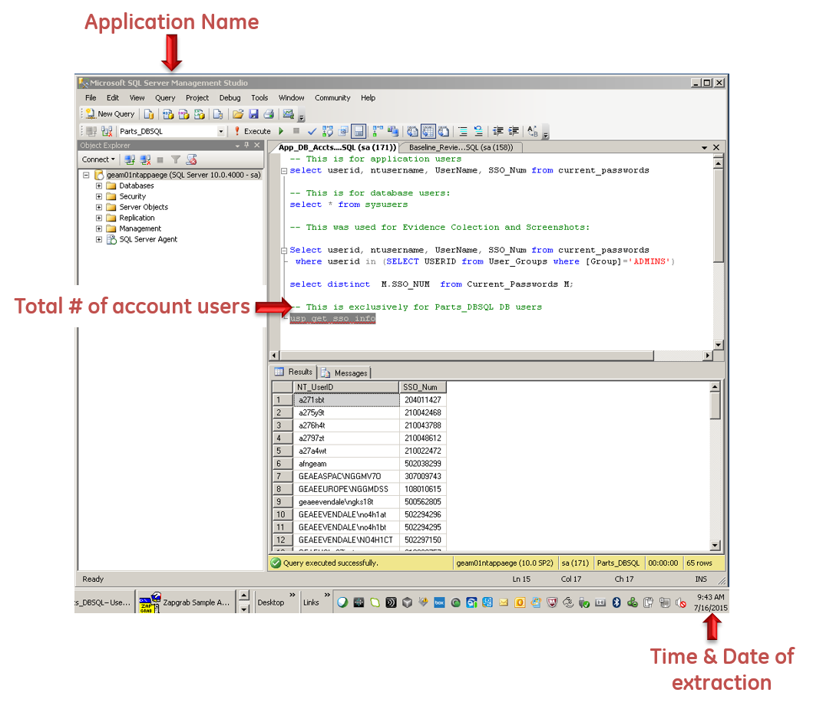Include in screen shots:

* Application Name
* Number of records
* Time and date

Defect Remediation – Submit your defect-free active user list

Notification - You will receive an email from the Access Review Workflow.

**When the Access Review workflow is returned to you, a Defect Review Report will be attached** identifying the users who do not have a business need for access to your asset.

Follow the instructions indicated in the Defect Report to disable unauthorized accounts:

* Inactive
* Revoked
* No Response from Manager
* OIA Review not Performed

**After remediating all defects**, generate a revised active user list. Attach the revised list and resubmit the Access Review Workflow.